# Project Title: Smart Water Fountains

# Objectives:

The Smart Water Fountain project aims to create an IoT-enabled water fountain system that provides an efficient, user-friendly, and data-driven approach to monitoring and managing water consumption. The primary objectives include:

**1. Water Conservation:** Monitor and regulate water flow to reduce wastage and promote responsible water consumption.

**2. User Experience:** Provide an intuitive interface for users to control the fountain and track water usage.

**3. Data Analytics:** Collect and analyze water consumption data for insights and optimization.

**4. Remote Control:** Allow users to control the fountain remotely via a web application.

**5. Alerts and Notifications:** Send alerts for unusual water usage patterns or low water levels.

**6. Sustainability:** Encourage responsible water usage and contribute to environmental conservation efforts.

# Diagram:

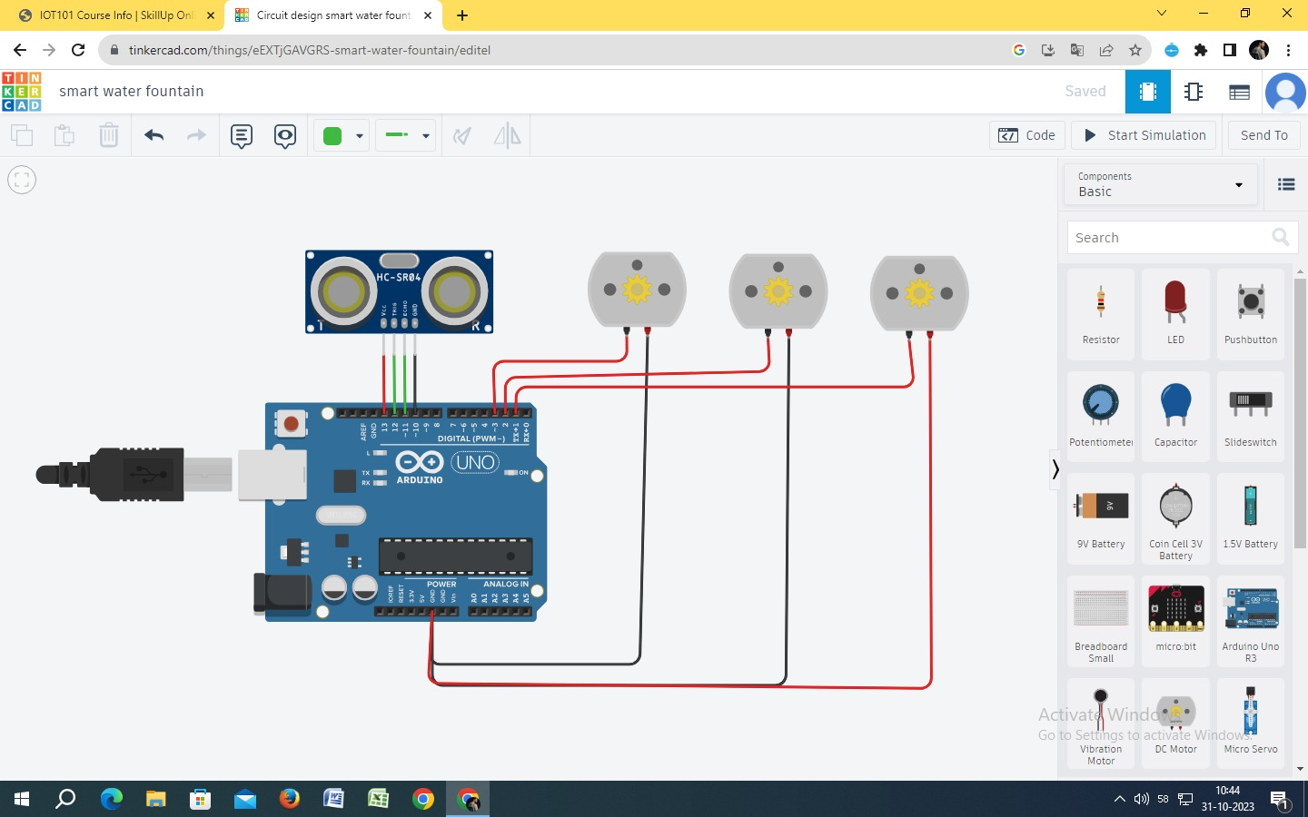

# WhatsApp Image 2023-10-31 at 11.06.04 AM.jpegSchematic Diagram:

# 50+ Free Arduino & Microcontroller Images - Pixabay

# IoT Sensor Setup:

The IoT sensor setup for the Smart Water Fountain includes the following components:

1. Flow Sensor: Monitors the rate of water flow through the fountain.

2. Water Level Sensor: Measures the water level in the fountain's reservoir.

3. Solenoid Valve: Controls the flow of water to the fountain.

4. Microcontroller (e.g., Arduino): Connects and manages the sensors and valve.

5. Wi-Fi Module: Enables the device to connect to the internet and communicate with the web application.

6. Power Supply: Provides electrical power to the sensors and microcontroller.

7. Enclosure: Protects the components from environmental conditions.

# Web Development Technologies:

The web application for the Smart Water Fountain is developed using modern web technologies. The technology stack may include:

**1. Front-end:**

- HTML5, CSS3, JavaScript: For building the user interface and interactivity.

- Frameworks like React, Angular, or Vue.js for a responsive and dynamic front-end.

- Charting libraries (e.g., Chart.js) for visualizing water usage data.

**2. Back-end:**

- Node.js, Python, or Ruby on Rails: For the server-side application.

- Express.js (Node.js) or Flask (Python) for routing and handling requests.

- Database (e.g., MongoDB, MySQL) to store user data and water consumption records.

- RESTful or GraphQL APIs for communication between the front-end and back-end.

**3. Cloud Services:**

- Amazon Web Services (AWS), Microsoft Azure, or Google Cloud Platform for hosting the application and database.

- IoT services for managing device connectivity and data storage.

- Authentication and authorization services for user accounts and security.

**4. Real-time Communication:**

- WebSocket or a library like Socket.io for real-time updates and remote control of the fountain.

# Code Implementation:

The code implementation can be divided into front-end and back-end components:

**Front-end:**

1. Design and develop the user interface with HTML, CSS, and JavaScript.

2. Implement user registration and authentication mechanisms.

3. Create a dashboard for users to monitor water usage, control the fountain, and receive alerts.

4. Use charting libraries to visualize water consumption data.

**Back-end:**

1. Set up the server using Node.js, Python, or your chosen technology.

2. Create API endpoints for user registration, authentication, and data retrieval.

3. Connect to the database to store and retrieve water consumption data.

4. Implement real-time communication for remote control of the fountain.

5. Integrate with IoT services to collect data from the sensors.

6. Implement data analysis algorithms for detecting unusual water usage patterns.

The IoT components will also require code to read sensor data and control the solenoid valve based on the input received from the web application. This code should establish communication with the web server and cloud services to exchange data.

The entire project requires a combination of hardware and software development, and it's essential to ensure data security, user privacy, and efficient water management. Regular testing, updates, and maintenance will be necessary to keep the Smart Water Fountain running smoothly.

# The real-time water fountain status system can promote water efficiency and public awareness in several ways:

**1.** **Data-Driven Insights:** By continuously monitoring the water fountain's status and water consumption, the system provides valuable data on water usage patterns. This data can be analyzed to identify trends, peak usage times, and potential areas for improvement. Insights derived from this data can guide water conservation efforts.

**2. Leak Detection:** Real-time monitoring can quickly detect leaks or abnormal water flow patterns. If a leak is detected, the system can send alerts to maintenance personnel or users, preventing significant water wastage and property damage.

**3.User Accountability:** The system encourages users to be more accountable for their water usage. When users can see real-time data on water consumption, they are more likely to be conscious of their usage and may adjust their behavior to reduce waste.

**4.Remote Control:** Allowing users to remotely control the water fountain through a web application means they can turn it on or off as needed. This feature empowers users to use water only when necessary, preventing water from being wasted when not in use.

**5.Public Awareness:** Public awareness is a key component of promoting responsible water use. The system can display real-time water consumption data on public displays or through social media. When the public is informed about water conservation efforts, they are more likely to participate and contribute to water-saving practices.

**6.Education:** The system can also include educational components, such as water conservation tips and information about the importance of responsible water usage. This information can be displayed on the web application or public displays near the water fountain.

**7.Competition and Rewards:** A real-time water status system can be gamified to encourage responsible water use. Users or communities can compete to reduce water usage, with rewards or recognition for the most efficient water savers. This competitive aspect can motivate individuals and communities to be more water-conscious.

**8.Community Involvement:** The system can facilitate community engagement by allowing users to set water-saving goals and participate in local water conservation initiatives. Communities can collaborate to reduce overall water consumption.

**9.Water Saving Challenges:** The system can periodically initiate water-saving challenges or campaigns, such as "Water-Saving Wednesdays" or "Summer Water Challenge," to encourage conscious water use during specific times or seasons.

In summary, the real-time water fountain status system not only helps to reduce water wastage and promote water efficiency but also serves as a tool for educating the public about the importance of responsible water use. By providing real-time data, alerts, and user controls, and by engaging the community in water-saving efforts, the system can contribute to both individual and collective efforts to conserve water and protect the environment.